**HardwareX article template**

*[Please fill in the template below and delete all instruction text in italics before submitting*.*]*

*GENERAL INFORMATION*

*HardwareX is an open access journal established to promote free and open source designing, building and customizing of scientific infrastructure (hardware). For more details on best practices for sharing open hardware see*[*http://www.oshwa.org/sharing-best-practices/*](http://www.oshwa.org/sharing-best-practices/)

**Title:**Weed Warden: A Low-Cost Weed Detection Device Implemented with Spectral Triad Sensor for Agricultural Applications

**Authors:** Liam Duncan, Brendan Miller, Colton Shaw, Ryan Graebner, Marcello Moretti, Cara Walter, John Selker, Chet Udell

**Affiliations: 1**Openly Published Environmental Sensing (OPEnS) Lab, OR, USA; **2**Department of Electrical Engineering and Computer Science Oregon State University, OR, USA; **3**Department of Biological and Ecological Engineering Oregon State University, OR, USA.

**Contact email:**duncanli@oregonstate.edu

**Abstract:**

Controlling weeds during the off season is essential for farmers to protect resources and maximize crop yield. Traditionally weeds are taken care of by spraying herbicides on the field. Herbicides can be harmful to the environment and spraying the entire field is expensive. Robotic weeders are a good solution to minimize environmental impact and save money on herbicides, but they are expensive (>$100,000). The Weed Warden is a low-cost (<$500) weed detection sensor that can be mounted on rovers or tractors. The Weed Warden uses a spectral triad sensor to detect weeds and can then trigger a weed removal system such as a sprayer when weeds are detected. The system uses the normalized difference vegetation index (NDVI) to measure the difference between near-infrared (which vegetation strongly reflects) and red light (which vegetation absorbs) to produce a value that ranges from -1 to +1 which will indicate if there is plant life under the sensor [1]. Weed Warden is a low-cost alternative to robotic weeders that can help reduce costs and pollution in agricultural settings.

**Keywords:** *Open-Source Hardware, Environmental Sensing, Spectral Sensing*

**Specifications table** *[please fill in right-hand column of the table below]*

|  |  |
| --- | --- |
| Hardware name | *Weed Warden* |
| Subject area | Environmental, Planetary and Agricultural Sciences |
| Hardware type | Field measurements and sensors |
| Open Source License | CERN Open Hardware License  GNU General Public License v3.0 |
| Cost of Hardware | $ 189.17 |
| Source File Repository | *DOI URL to an approved source file repository:* [*OSF*](https://osf.io/wgk7q/wiki/home/)*,* [*Mendeley Data*](https://data.mendeley.com) *or* [*Zenodo*](https://doi.org/10.5281/zenodo.3356702)*. For example:* <http://doi.org/10.17605/OSF.IO/WGK7Q> |

1. **Hardware in context**

The most common method for weed removal today is to spray herbicide onto a field which will eliminate the weeds. This method can introduce large amounts of pollutants into the environment and end up being very expensive. A recent method to combat pollution and reduce long term costs is to use a commercial robotic weeder that spots and targets weeds to use less herbicide. An example of a robotic weeder is the one from [ecorobotix](https://www.ecorobotix.com/en/autonomous-robot-weeder/) [2]. This robot saves costs by cutting down on the amount of herbicide needed to rid the field of weeds. The issue with commercial weeding robots is that they are expensive (>$150,000) and do not utilize equipment that farmers already have.

In contrast, the Weed Warden, a system for sensing weeds and triggering external equipment, is low cost (<$500) and modular. The Weed Warden utilizes a low-cost spectral triad sensor and can detect weeds from up to three feet off the ground. The Weed Warden can be attached to any equipment that the farmer already owns (e.g. tractor) or put onto a dedicated rover to remove weeds autonomously. This allows farmers to save costs by using equipment that they already own and still getting the cost and environmental benefits of spot spraying.

1. **Hardware description.**

The Weed Warden consists of 2 stacked PCBs and the [AS7265x Spectral Triad Sensor](https://www.sparkfun.com/products/15050) from Sparkfun. The main PCB assembly (figure 2.2) consists of an [Adafruit Feather M0 board](https://www.adafruit.com/product/2772) with an OPEnS Lab Hypnos board stacked on top. The Feather M0 serves as the controller and the Hypnos for power management/datalogging. Figure 2.1 shows a block diagram for the Weed Warden including the Feather M0, Hypnos Board, Triad Sensor, External Sprayer Device, and optional 12V to 5V buck converter.

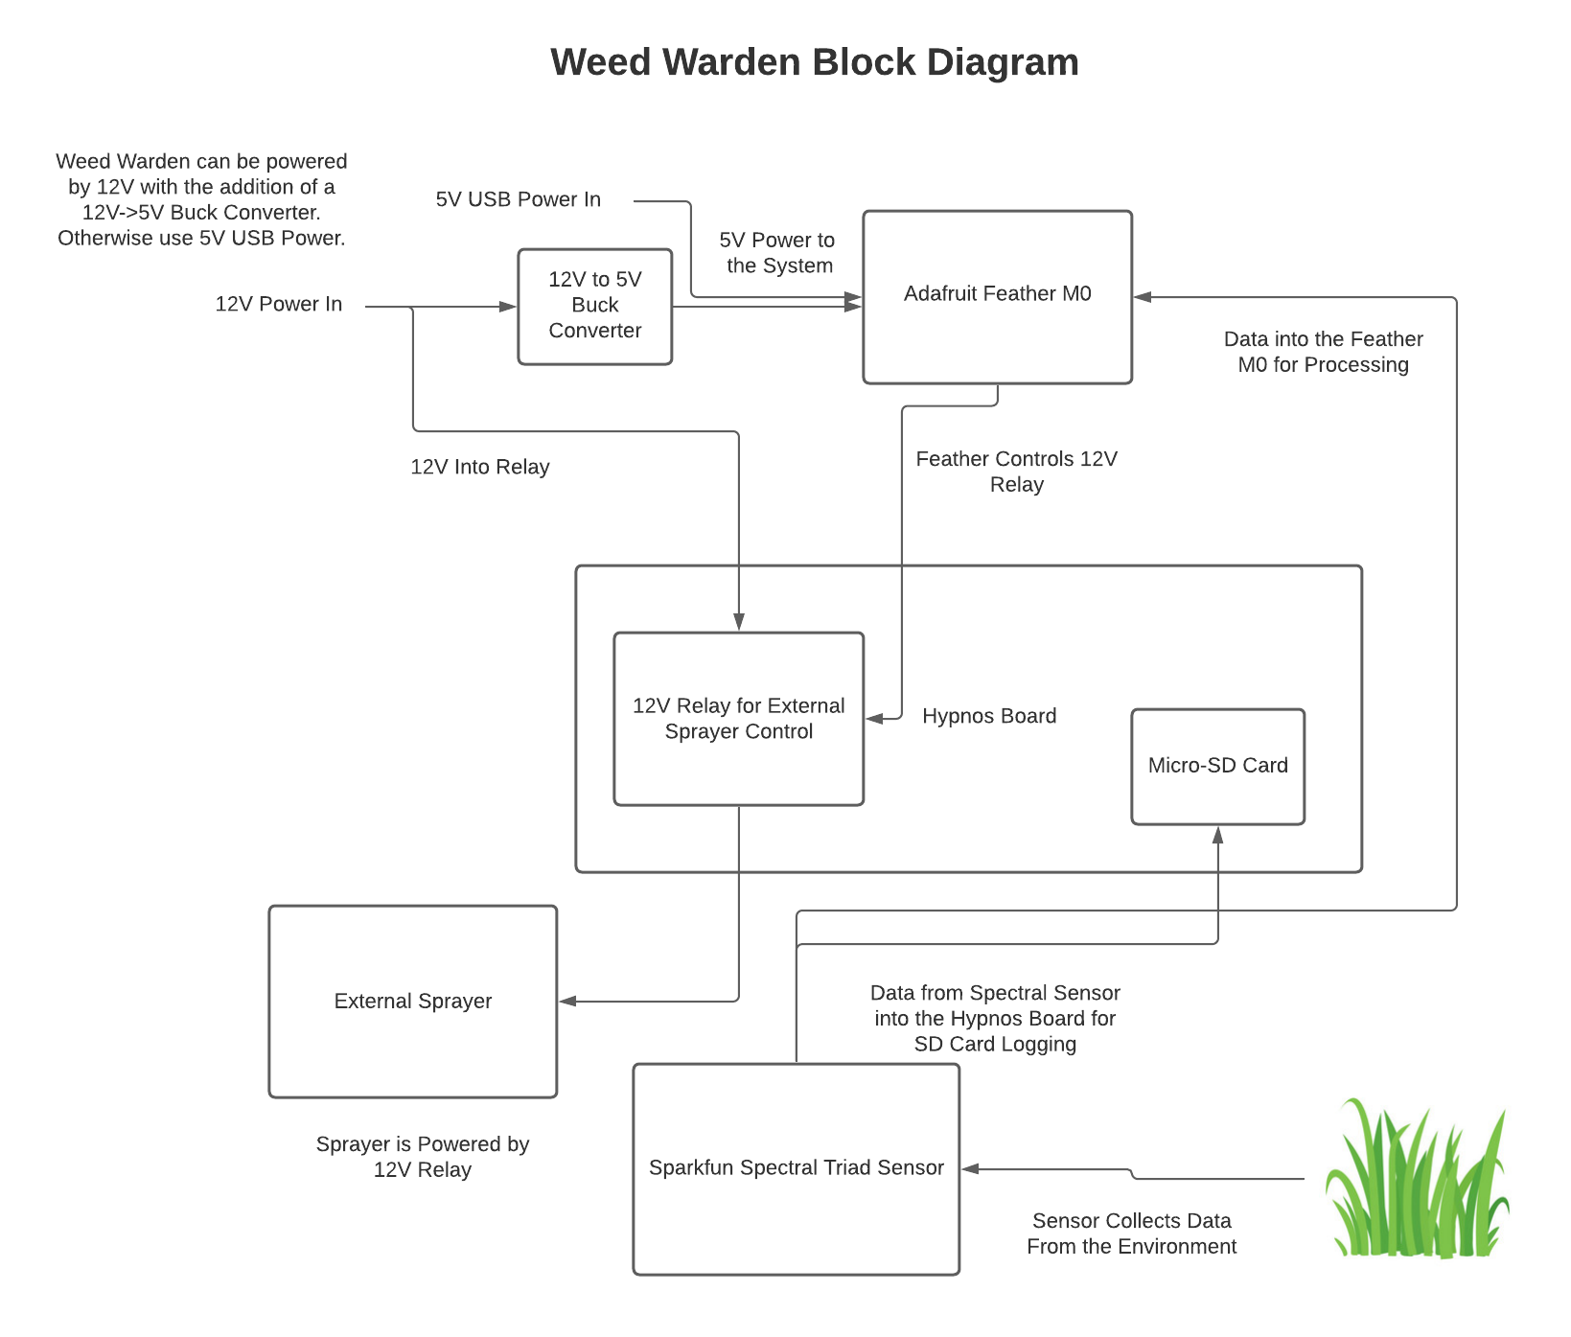

Figure 2.1: Block Diagram of the System

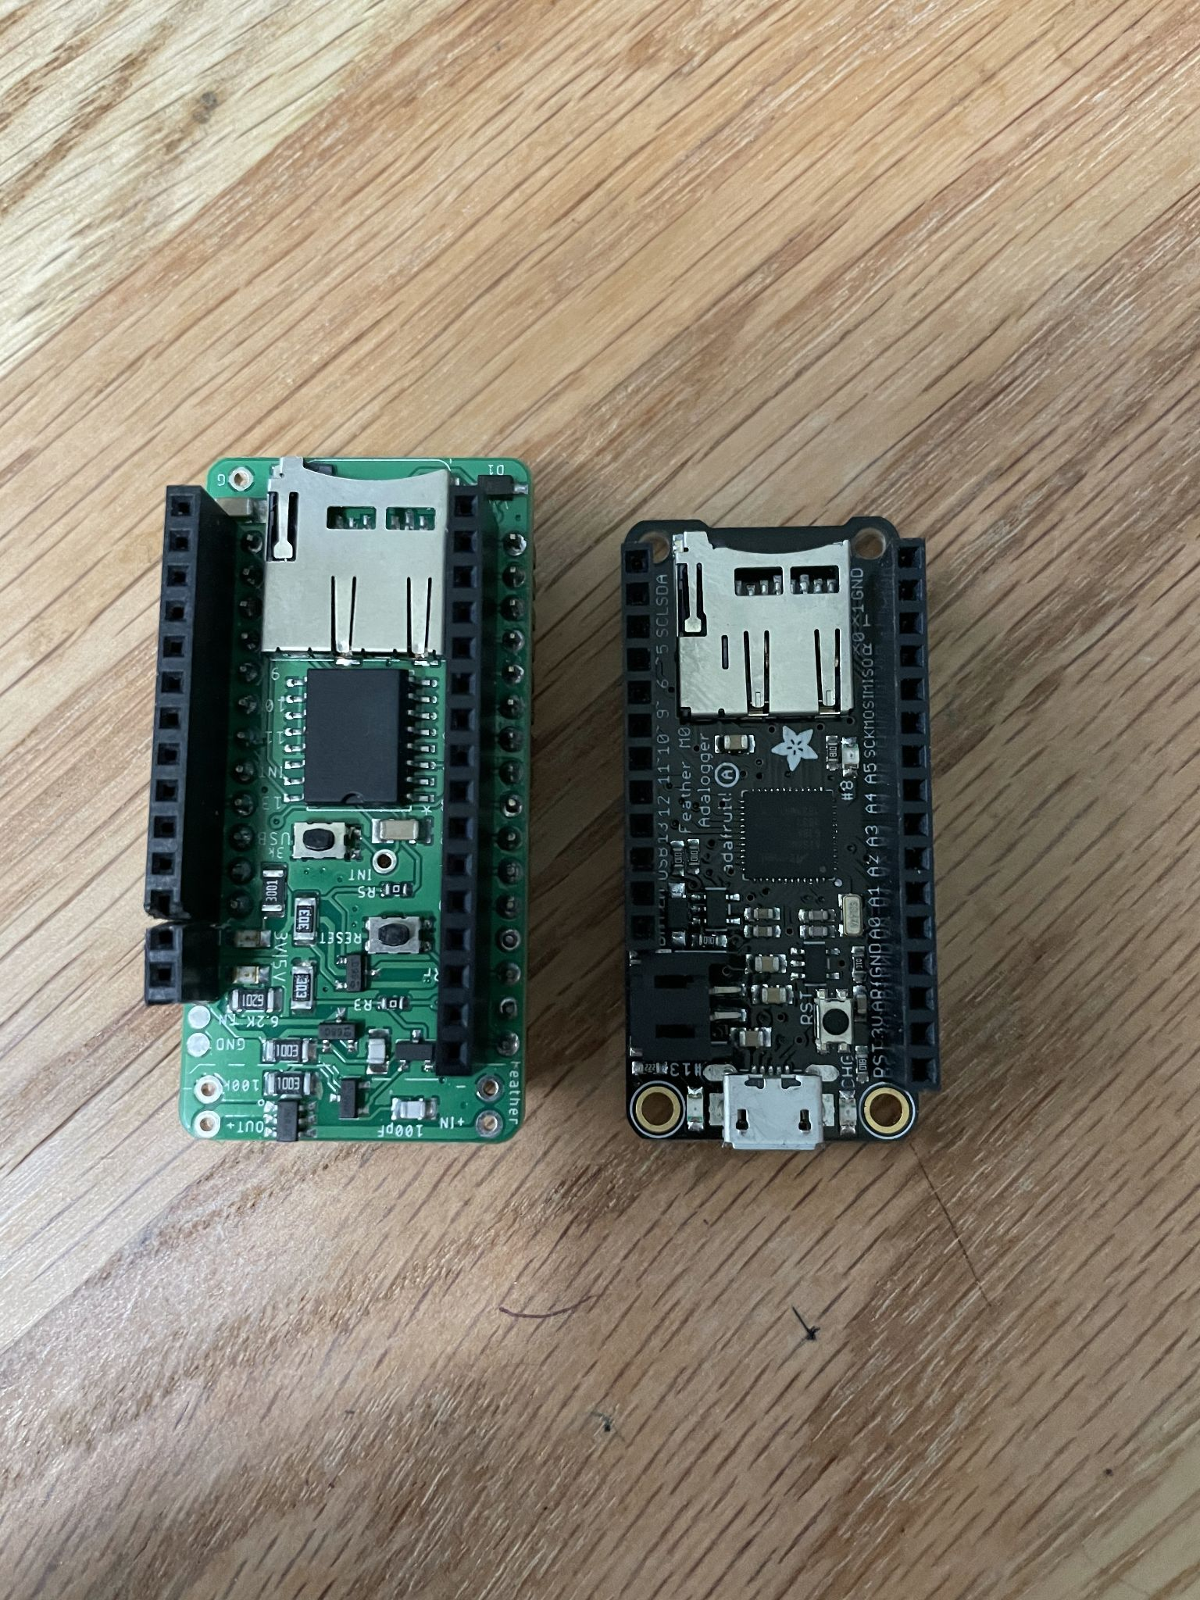

Figure 2.2: Main PCB Assembly. OPEnS Lab Hypnos board on the right and Adafruit Feather M0 on the right.

The Weed Warden offers a platform for the user to not only detect plants with NDVI, but also can detect 18 different frequencies of light allowing for custom algorithms. The Weed Warden can be powered by 5V USB, [3.7V Adafruit Lithium Ion Battery](https://www.adafruit.com/product/2011?gclid=Cj0KCQiA-aGCBhCwARIsAHDl5x8HlolkO2D299viGmSNjGxvbigBHO13EveKj-JsVxovBAae1pkZXjQaAqyCEALw_wcB), or through a [12V Power Jack](https://www.adafruit.com/product/368) with a [5V buck converter](https://www.adafruit.com/product/1385). The Weed Warden used in this article was powered by 5V USB. Furthermore, the Hypnos board offers full control of 3.3V and 5V power rails as well as an external power supply up to 24V/2A that can be used to toggle a sprayer or any other device. Other features include the ability to log data to microSD, a well-known interface through Arduino, and the ability to expand the system by adding more spectral triad sensors. The hardware is encased in a Nanuk 904 weatherproof box allowing for use in a variety of conditions.

● Plant detection with NDVI algorithm.

● MicroSD datalogging.

● Sensor provides 18 different wavelengths which supports custom detection algorithms.

● Up to 24V/2A power rail control for accessories such as sprayers.

1. **Design files**

**Design Files Summary**

|  |  |  |  |
| --- | --- | --- | --- |
| Design file name | File type | Open source license | Location of the file |
| *Custom PCB Schematic* | SCH | CERN Open Hardware License |  |
| Custom PCB Board | BRD | CERN Open Hardware License |  |
| Arduino Code | .ino | GNU General Public License v3.0 |  |

Custom PCB Schematic:

This file contains the EAGLE schematic of the Custom PCB Breakout board.

Custom PCB Board:

This file contains the EAGLE board layout for the Custom PCB Breakout board.

Arduino Code:

The Arduino code is the code that must be uploaded to the Feather M0 in order to use the Weed Warden. The code contains the calibration sequence and plant detection, data logging, and Hypnos Relay control.

1. **Bill of Materials**

*[For a complex Bill of Materials, the complete Bill of Materials (editable spreadsheet file e.g., ODS file type or PDF file) can be uploaded in an open access online location such as the* [*Open Science Framework*](https://osf.io/)*repository. Include the link here. Alternatively, the Bill of Materials can be uploaded at the time of submission on the online Elsevier submission interface as supplementary material.]*

**Bill of Materials**

|  |  |  |  |  |  |  |
| --- | --- | --- | --- | --- | --- | --- |
| Designator | Component | Number | Cost per unit - USD | Total cost -  USD | Source of materials | Material type |
| Feather M0 | *Feather M0* | 1 | 19.95 | 19.95 | [Adafruit](https://www.adafruit.com/product/2772) | Other |
| Triad Sensor | Spectral Triad Sensor | 1 | 64.95 | 64.95 | [SparkFun](https://www.sparkfun.com/products/15050) | Other |
| Hypnos Board | OPEnS Lab Hypnos Board | 1 | 33.00 | 33.00 | [OPEnS Lab](https://github.com/OPEnSLab-OSU/OPEnS-Hypnos) | Other |
| Coin cell Battery **** | Coin Cell Battery | 1 | 1.95 | 1.95 | [Spark Fun](https://www.sparkfun.com/products/337) | Other |
| Hard Case | Nanuk 904 Waterproof Hard Case with Foam Insert | 1 | 35.19 | 35.19 | [*Amazon*](https://www.amazon.com/Nanuk-Waterproof-Hard-Case-Insert/dp/B00BP8V87A) | Polymer |
| 12V Buck Converter ***** | UBEC DC/DC Step Down Converter | 1 | 9.95 | 9.95 | [Adafruit](https://www.adafruit.com/product/1385) | Other |
| M3 Screws | Metric Steel Pan Head Phillips Screws M3 x 0.5 mm Thread | 1 | 3.48 * | 3.48 | [*McMaster Carr*](https://www.mcmaster.com/92005A128/) | Metal |
| M3 Hex Nut | Thin Steel Hex Nut M3 x 0.5 mm Thread | 1 | 3.51 * | 3.51 | [*McMaster Carr*](https://www.mcmaster.com/90695A033/) | Metal |
| JST Connector | 4 Pin JST Connectors | 1 | 7.99 ** | 7.99 | [*Amazon*](https://www.amazon.com/Micro-Connector-150mm-Cable-Female/dp/B01DUC1S7S) | Other |
| Female Pin Headers | Header Kit for Feather 12 Pin and 16 Pin Female Header Set | 2 | 0.95 | 0.95 | [*Adafruit*](https://www.adafruit.com/product/2886) | Other |
| Male Pin Headers | Short Feather Male Headers - 12-pin and 16-pin Male Header Set | 1 | 0.50 | 0.50 | [*Adafruit*](https://www.adafruit.com/product/3002) | Other |
| Stacking Pin Headers | Stacking Headers for Feather - 12-pin and 16-pin female headers | 1 | 1.25 | 1.25 | [*Adafruit*](https://www.adafruit.com/product/2830) | Other |
| Micro SD Card | SanDisk Ultra 32GB UHS-I/Class 10 Micro SDHC Memory Card | 1 | 8.45 | 8.45 | [*Amazon*](https://www.amazon.com/SanDisk-Ultra-UHS-I-Memory-Adapter/dp/B00M55C0NS/ref=sr_1_14?dchild=1&keywords=micro+sd+card&qid=1613421813&sr=8-14) | Other |
| Sensor Cover | Flanged Weatherproof with PG-7 Cable Glands *** | 1 | 9.95 | 9.95 | [*Adafruit*](https://www.adafruit.com/product/3931) | Polymer |

*\* Pack of 100*

*\*\* Pack of 20*

*\*\*\* Only need the lid from the box*

*\*\*\*\* Optional component. This Component is for the Hypnos RTC and is not necessary for the Weed Warden to work.*

*\*\*\*\*\* Optional Component. Use this converter if a 12V Power Source is being used to power the Weed Warden.*

*[Provide additional description of the Materials used here:]*

1. **Build Instructions** *[Provide detailed, step by step instructions for the construction of the reported hardware:*

* *Include all necessary information for reproducing the submitted hardware.*
* *Explain and, when possible, characterize design decisions. Including design alternatives if they exist.*
* *Use visual instructions such as schematics, images, and videos.*
* *Clearly reference design files and component parts described in the* **Design File Summary** *and* **Bill of Materials**.
* *Highlight potential safety concerns that may arise. ]*

5.1 PCB Assembly

The first step to assemble the Weed Warden is to assemble the four PCBs. Each PCB will be gone over in detail in the following sections. Weed Warden PCB assembly involves soldering which can be dangerous, please follow soldering safety guidelines to reduce the intrinsic hazards associated with soldering.

5.1.1 Feather M0 Assembly

In order to assemble the Feather M0, the female pin headers must be attached to the Feather M0 PCB. The [official Adafruit guide](https://learn.adafruit.com/adafruit-feather-m0-basic-proto/assembly) provides the instructions for Soldering on Female Headers [3].

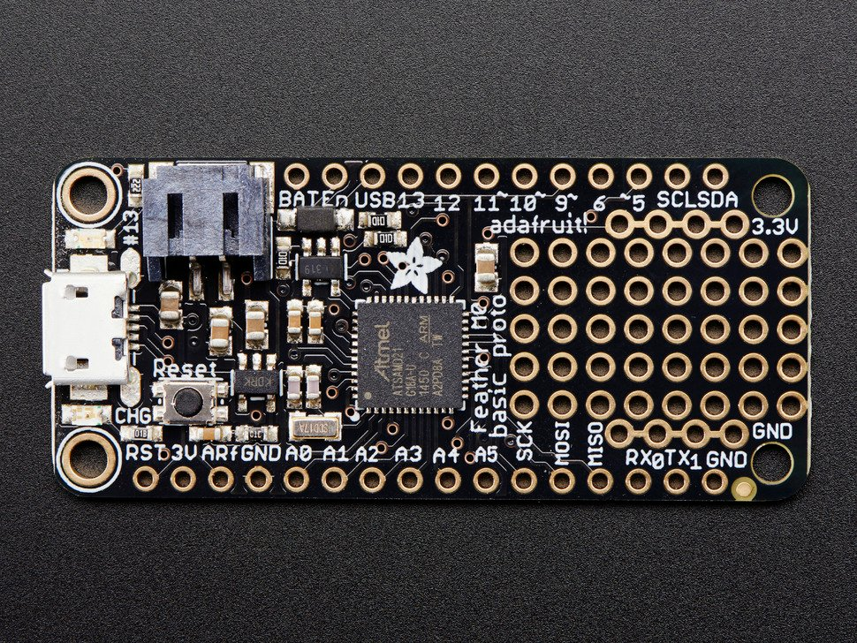

Figure 5.1.1.1: Feather M0

5.1.2 Hypnos Board Assembly

The next PCB that must be assembled is the Hypnos Board. [The official Hypnos GitHub wiki](https://github.com/OPEnSLab-OSU/OPEnS-Lab-Home/wiki/Hypnos) contains the [official build guide](https://www.youtube.com/watch?v=zoqtSttL0x4) which should be followed when assembling the Hypnos Board [4]. The build guide covers how to place all SMD components onto the Hypnos board. The next step is to attach female pin headers on the topside of the board and male pin headers on the bottom side of the board. Solder female pin headers to the top side of the board on the Hypnos control line (Figure 5.1.2.1) [5]. Flip the board over and solder male pin headers to the feather line (Figure 5.1.2.2).

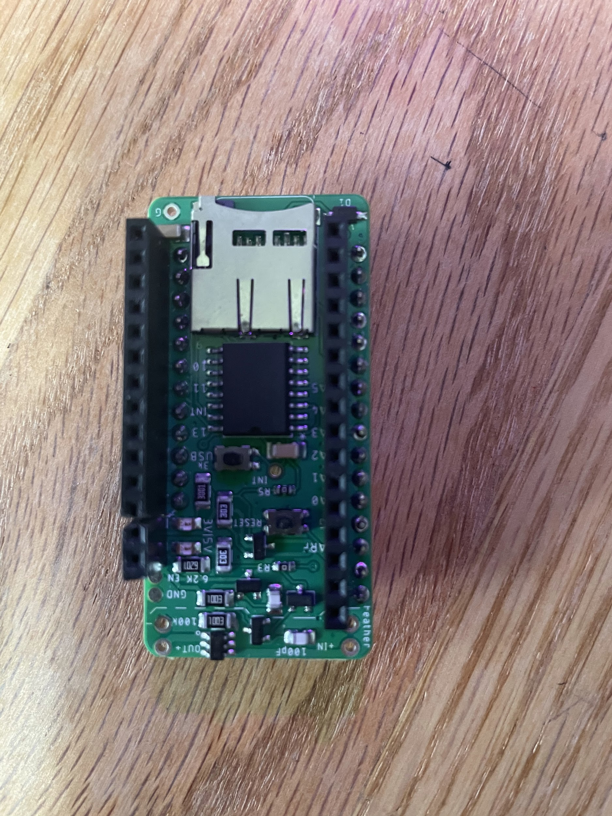

Figure 5.1.2.1: Top side of Hypnos Board assembled with female pin headers on control rail.

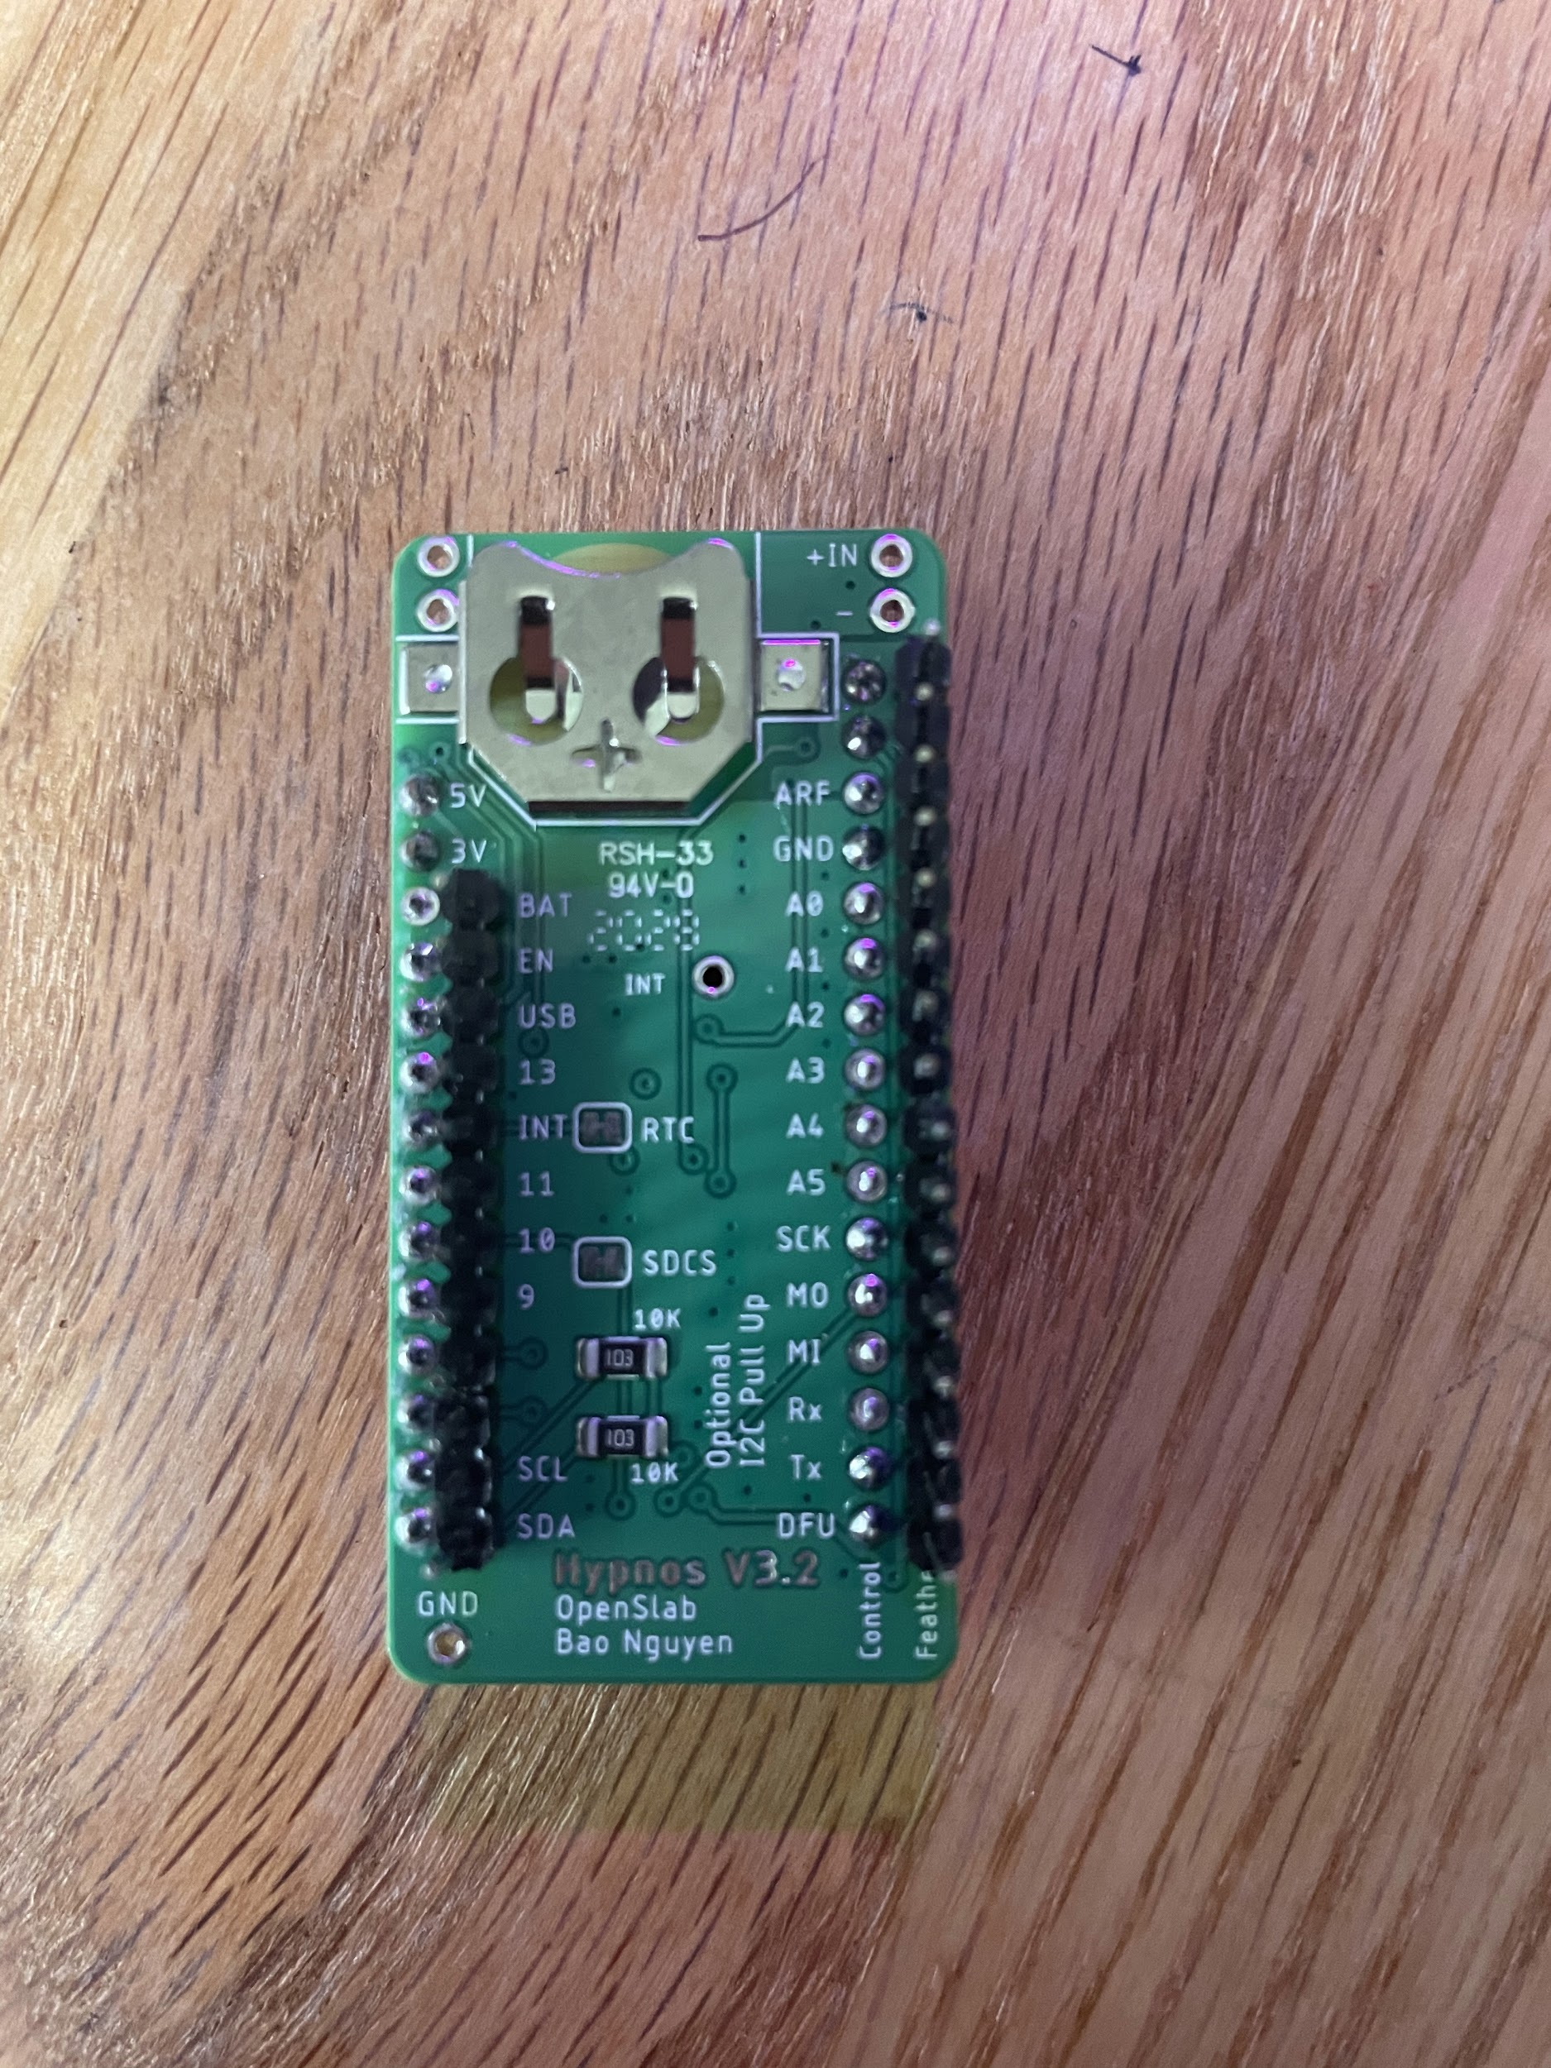

Figure 5.1.2.2: Bottom side of Hypnos Board assembled with male pin headers on feather rail.

5.1.3 Triad Sensor Assembly

The last PCB that must be assembled is the Triad sensor. The only component that needs to be connected is the female end of the JST Connector. Solder the Female JST connector socket onto the Spectral triad board where the I2C connections are (Figure 5.1.4.1).

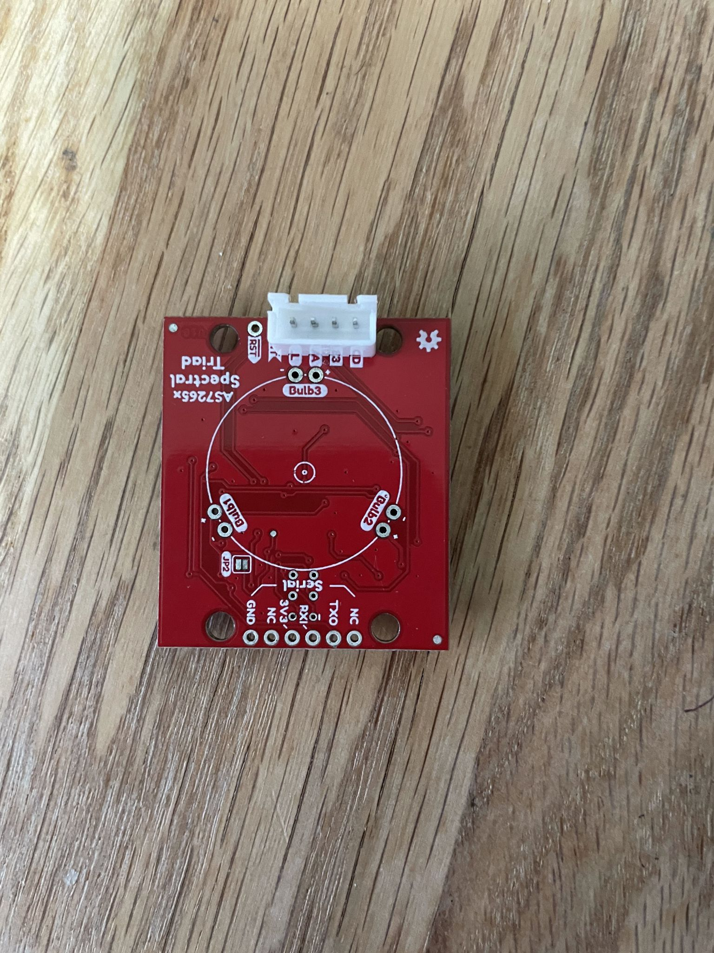

Figure 5.1.3.1: Triad Sensor with JST Connector attached

5.2 Hard Case Modifications

In order to make the hard case work for the Weed Warden some modifications must be done. Modifying the hard case involves using a drill, please use safe drilling practices. The first modification will be to drill holes in the top of the box to mount the sensor cover on and holes to mount the triad sensor. A hole must also be drilled to accommodate the JST Connector for the triad sensor.

5.2.1 Sensor Cover Holes

The holes for the sensor cover must be drilled to 8.84 cm x 5.58 cm to accommodate for the sensor cover*.* Use a M4 drill bit for the holes. Reference figure 5.2.1.1 below for an example of drilled sensor cover holes.

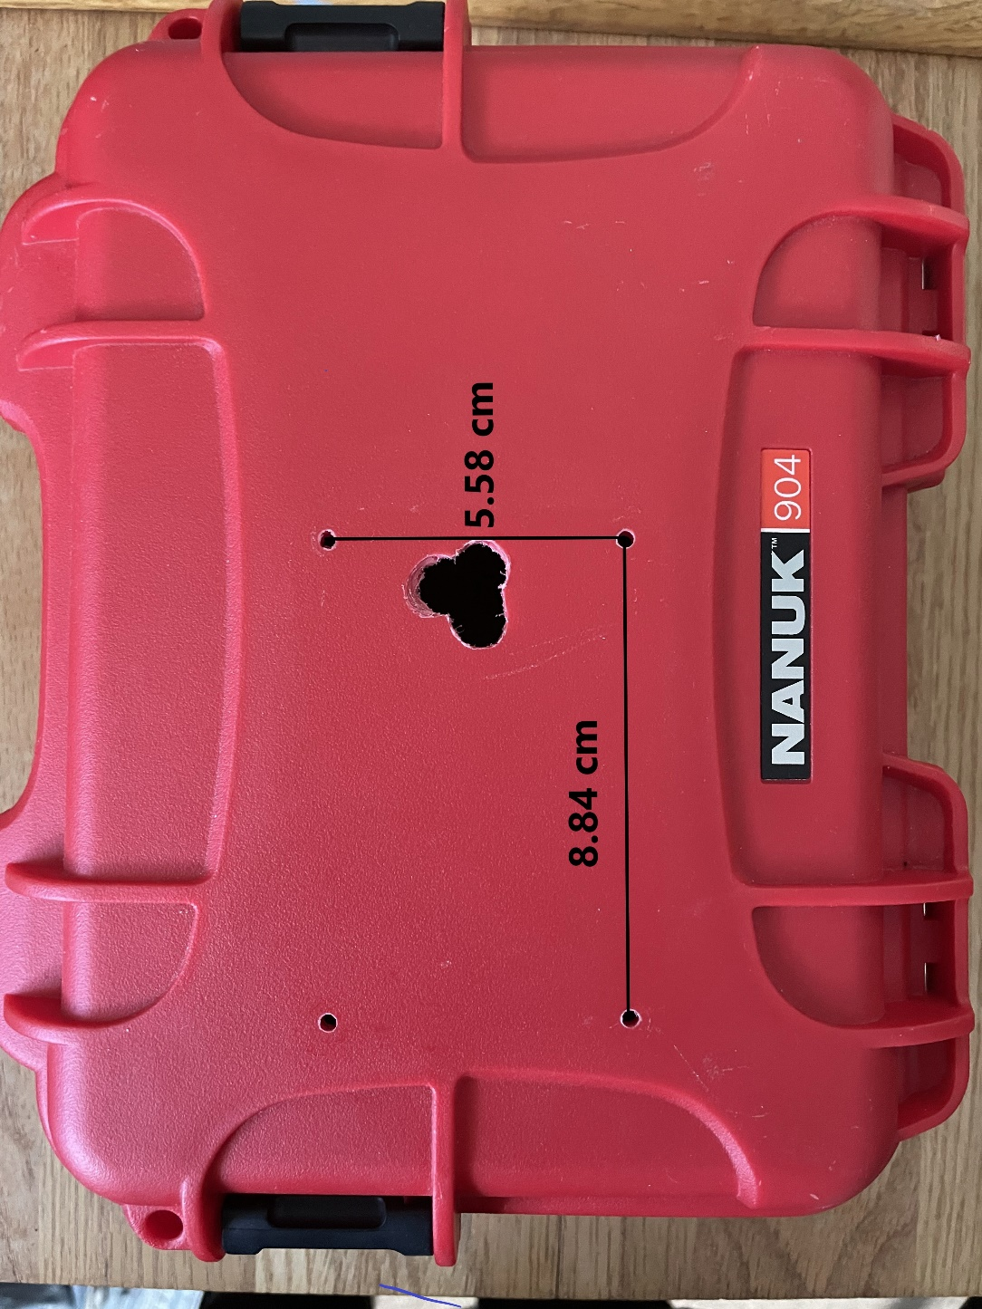

Figure 5.2.1.1: Sensor cover mounting holes and wire through hole.

5.2.2 Triad Sensor Mounting Holes

The triad sensor must be mounted on top of the hard case underneath the sensor cover. Drill 4 M4 holes centered around the center of the sensor cover at the dimensions of the mounting holes for the triad sensor. Figure 6 shows the proper holes for the triad sensor mounting.

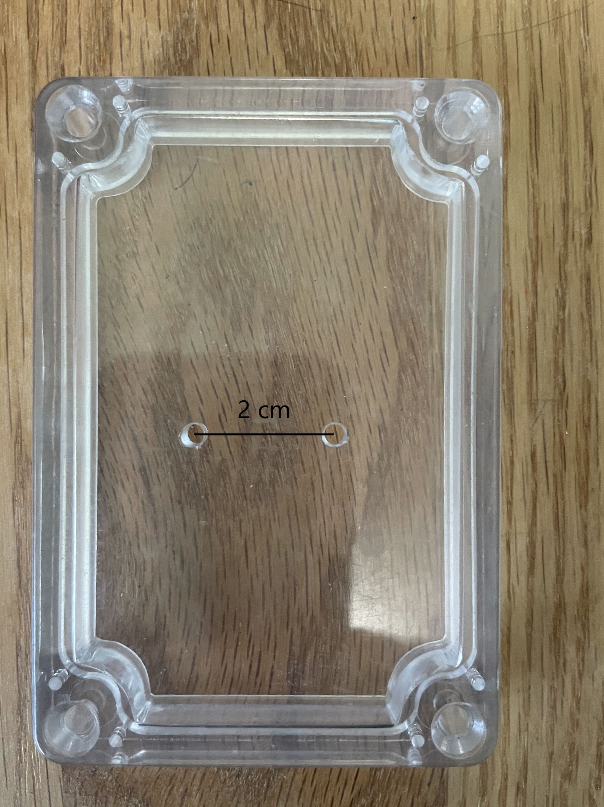

Figure 5.2.2.1: Triad sensor mounting holes on the sensor cover.

5.2.3 Drilling Wire Hole

A hole must be drilled in the hard case to allow the JST connector wires through. Drill a hole in the hard case in the spot where the wires will go through that is large enough to accommodate the male end of the JST Connector1.5 cm works. Reference figure 5.2.1.1 below for the sensor wire hole.

5.3 JST Connector Wiring

The JST Connector must be connected to some pin headers or directly soldered to the Hypnos Board PCB.

*Insert picture of wire connections for the JST Connectors. figure 8*

5.4 Putting it All Together

Now that all the components are prepared the Weed Warden can be assembled.

5.4.1 PCB Stacking

The two PCBs will be stacked with the Feather M0 on the bottom and the Hypnos on the top Figure 5.4.1.1.

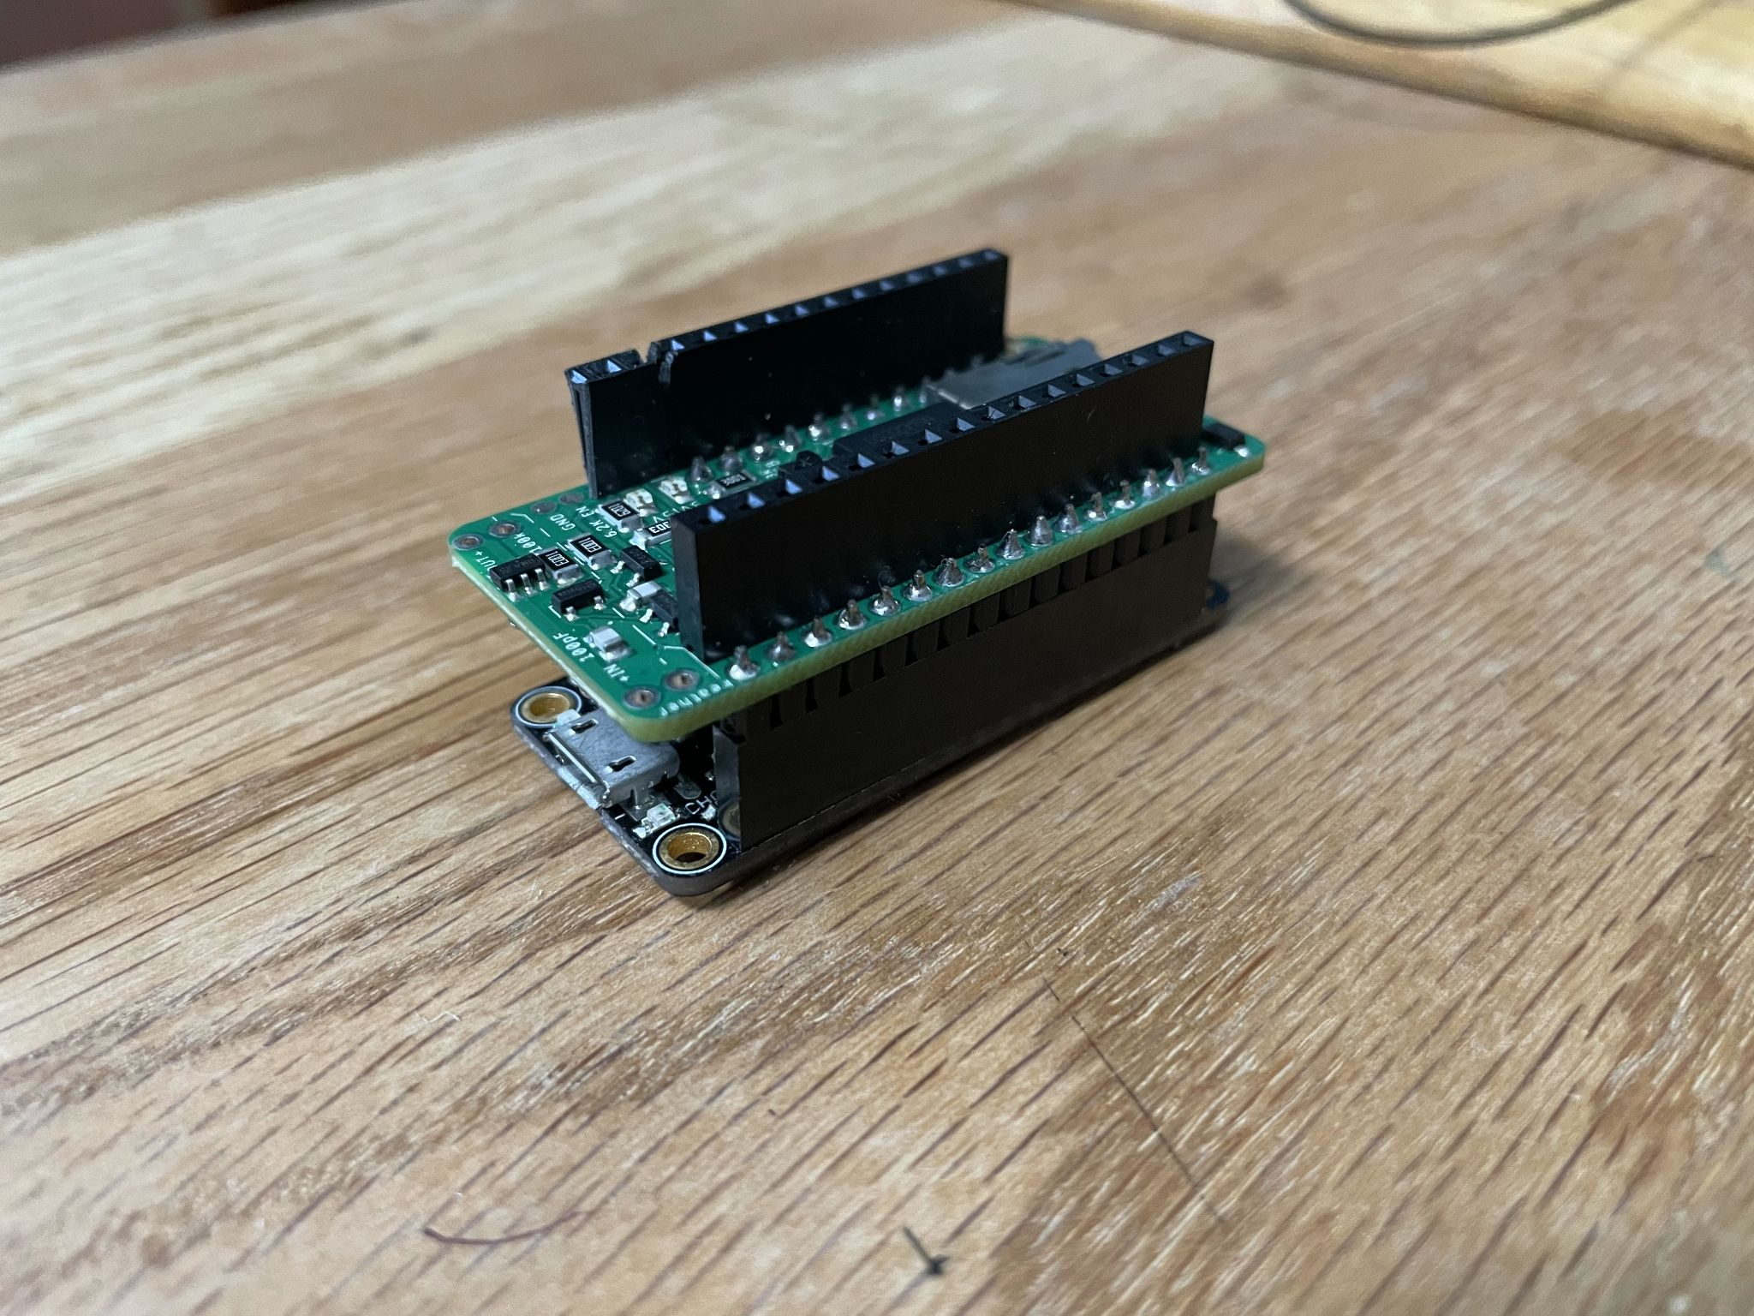

Figure 5.4.1.1: Stacked PCBs with the Feather M0 on the bottom and the Hypnos Board on top.

5.4.2 Sensor Mounting

Once the PCBs are connected, the Triad Sensor and sensor cover must be mounted onto the hard box. Using the M3 screws and M3 hex nuts, attach the triad sensor to the hard case using the screw holes that were created in step 5.2.2. Next, mount the sensor cover to the hard case using the holes drilled in step 5.2.1. The assembly should look like figure 5.4.2.1.

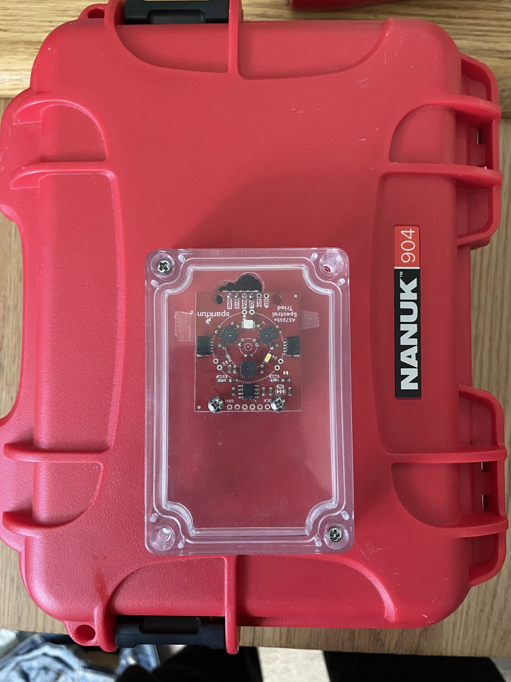

Figure 5.4.2.1: Sensor cover, and sensor mounted on hard case.

5.4.3 JST Connection

The final step is to connect the triad sensor to the custom PCB with the spliced JST connectors. Simply plug the 2 boards together and the assembly is finished. Figure 11 shows the completed assembly.

*Insert figure 11 the completed assembly.*

1. **Operation Instructions** *[Provide detailed instructions for the safe and proper operation of the hardware.*

* *Step-by-step operational instructions for operating the hardware.*
* *Use visual instructions as necessary.*
* *Highlight potential safety hazards.]*

1. Plug a micro-USB cable into the Feather M0 and plug the other end into a PC that has [Arduino IDE](https://www.arduino.cc/en/software) installed. Version 1.8.13 was used for our testing. Follow the [Instructions](https://github.com/OPEnSLab-OSU/Loom/wiki/Quick-Start) for setting up Loom (we used version 2.5.0) on the Feather M0 and use the configuration file that is included in the Zenodo repository [6]. Figure 6.1 shows an example of Weed Warden USB cable routing out of the Hard Case.

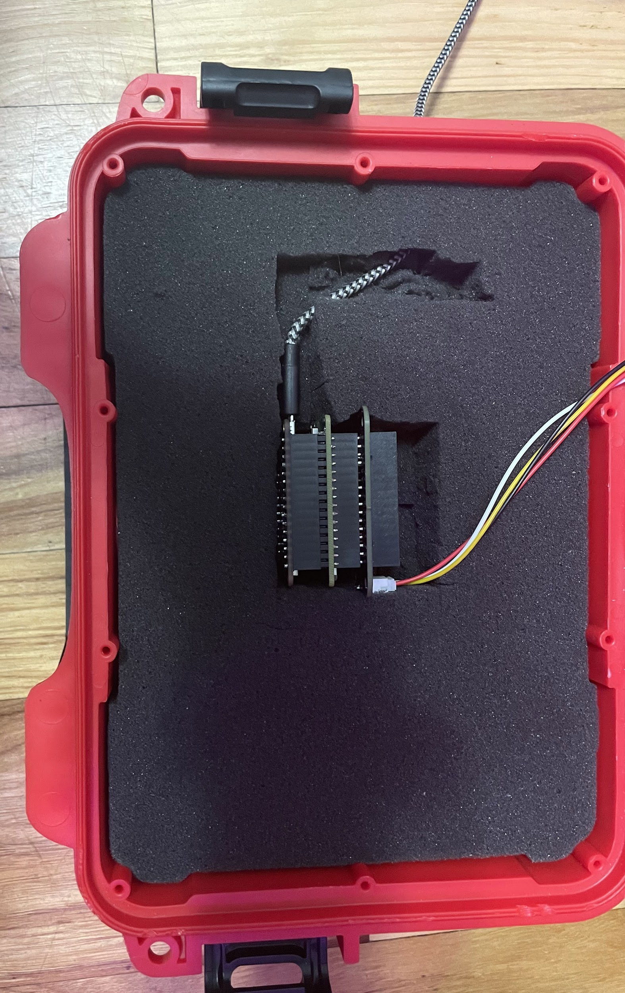

Figure 6.1: Picture of the Weed Warden with USB Cable routed out of the Hard Case

1. Flash the Weed Warden code from the Zenodo repository onto the feather M0. To upload the code to the Arduino the correct port must be selected from the tools->ports menu. The default algorithm for the Weed Warden is to use NDVIB.

Optional: modify the code to use a different algorithm or threshold offset. To do this you must modify the code. A screenshot of the code can be found in figure 6.2. In order to use a custom algorithm the user must modify line 141 and set the index variable equal to th;e desired index.

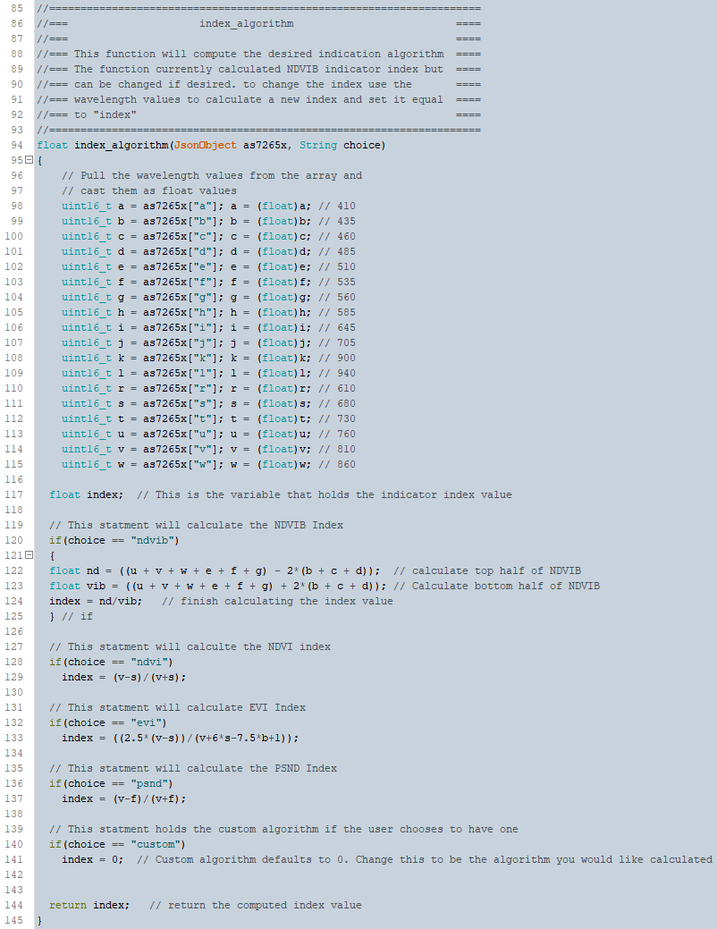

Figure 6.2: Screenshot of index algorithm function. Algorithm can be changed on line 141.

1. Position the sensor over a patch of dirt that does not have any vegetation present at the desired (see figure 6.3 for radius of detection values) height and plug the sensor in to power from the USB. Wait for about 30 seconds for the sensor to calibrate itself. The calibration will take readings of the dirt sample and generate a calibration threshold that will later be used to determine the presence of vegetation. Calibration status can be viewed in the serial monitor. If the optional buzzer is installed, the system will beep loudly for 5 seconds when calibration is complete. Figure 6.4 shows an example testing setup with the sensor positioned over a dirt surface for calibration. Mounting for the Weed Warden can be done according to the application by drilling holes in the hard case and using the mounting method of your choice.

|  |  |
| --- | --- |
| Height (feet) | Radius of Detection (inches) |
| 1 | 4.48 |
| 2 | 8.88 |
| 3 | 13.44 |

Figure 6.3: Radius of detection and height table.

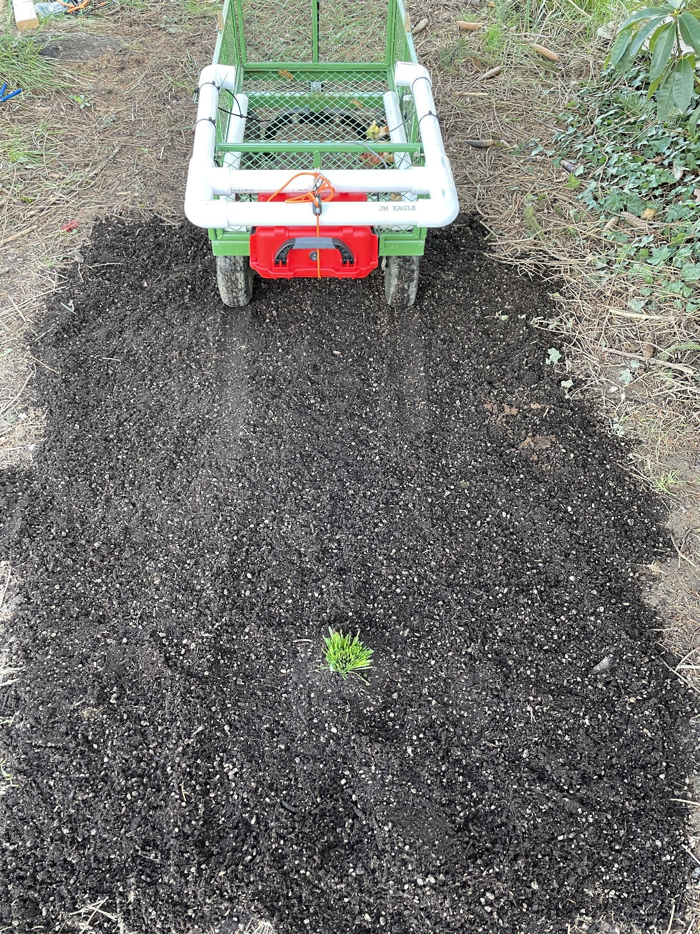

Figure 6.4: Picture shows an example testing setup for Weed Warden at 16” height.

1. Once the sensor is calibrated it is ready to detect vegetation. In order to detect the vegetation, an indicator index is generated from the NDVI value which is then compared to the calibration threshold which is generated by scanning a plain dirt sample. If the indicator index value crosses the calibration threshold, the 12V relay will be triggered and any devices connected to the relay will be turned on while the indicator index is above the calibration threshold. 12V devices will be turned off when the indicator index falls below the calibration threshold.
2. **Validation and Characterization** *[Demonstrate the operation of the hardware and characterize its performance over relevant critical metrics:Demonstrate the use of the hardware for a relevant use case.*

* *If possible, characterize performance of the hardware over operational parameters.*
* *Create a bulleted list that describes the capabilities (and limitations) of the hardware. For example consider descriptions of load, operation time, spin speed, coefficient of variation, accuracy, precision and etc.*

To validate the Weed Warden’s effectiveness the system must be able to:

* Detect vegetation at a 16” and 12” height.
* Detect all live vegetation samples that are larger than 3” x 3”.
* Log all data to an SD card.
* Be Weatherproof

**7.1 Testing Procedure**

In order for these parameters to be tested a consistent setting was needed. To create a consistent testing environment, a bag of potting soil was used to create a 5’ x 7’ dirt surface (figure 7.1), and a grass bundle was created to simulate a plant (figure 7.2).

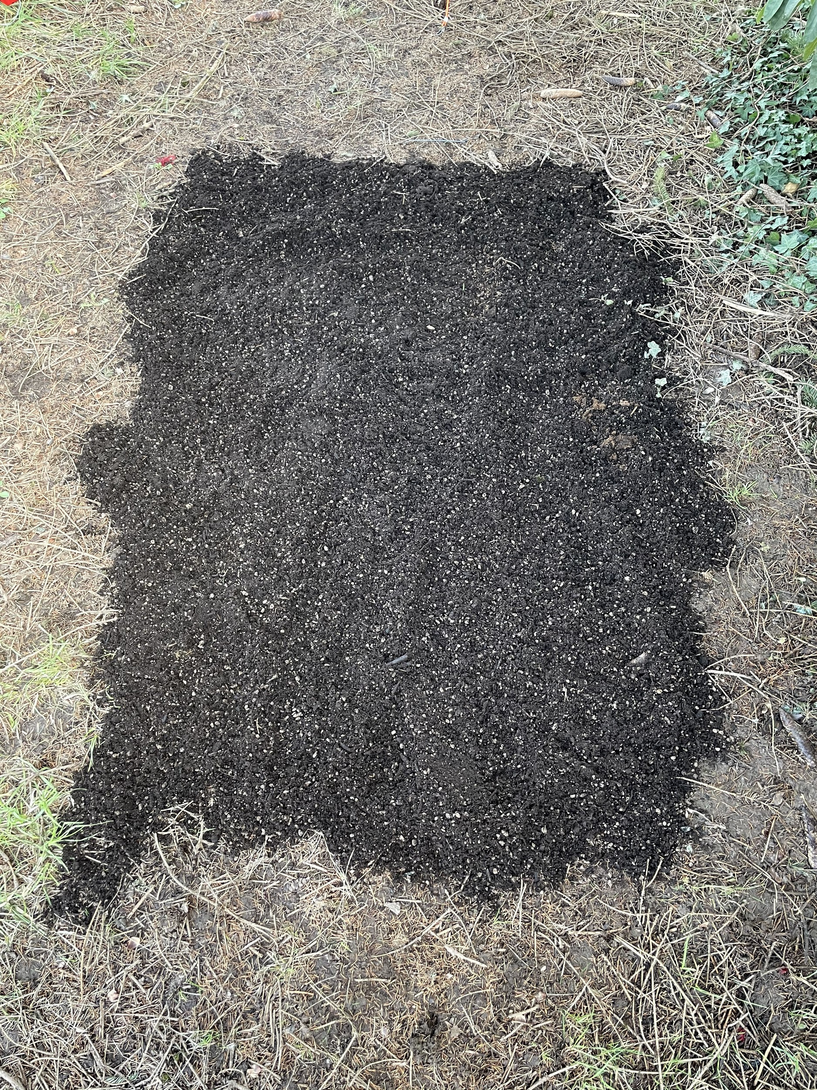

Figure 7.1.1: A bare patch of dirt made of potting soil

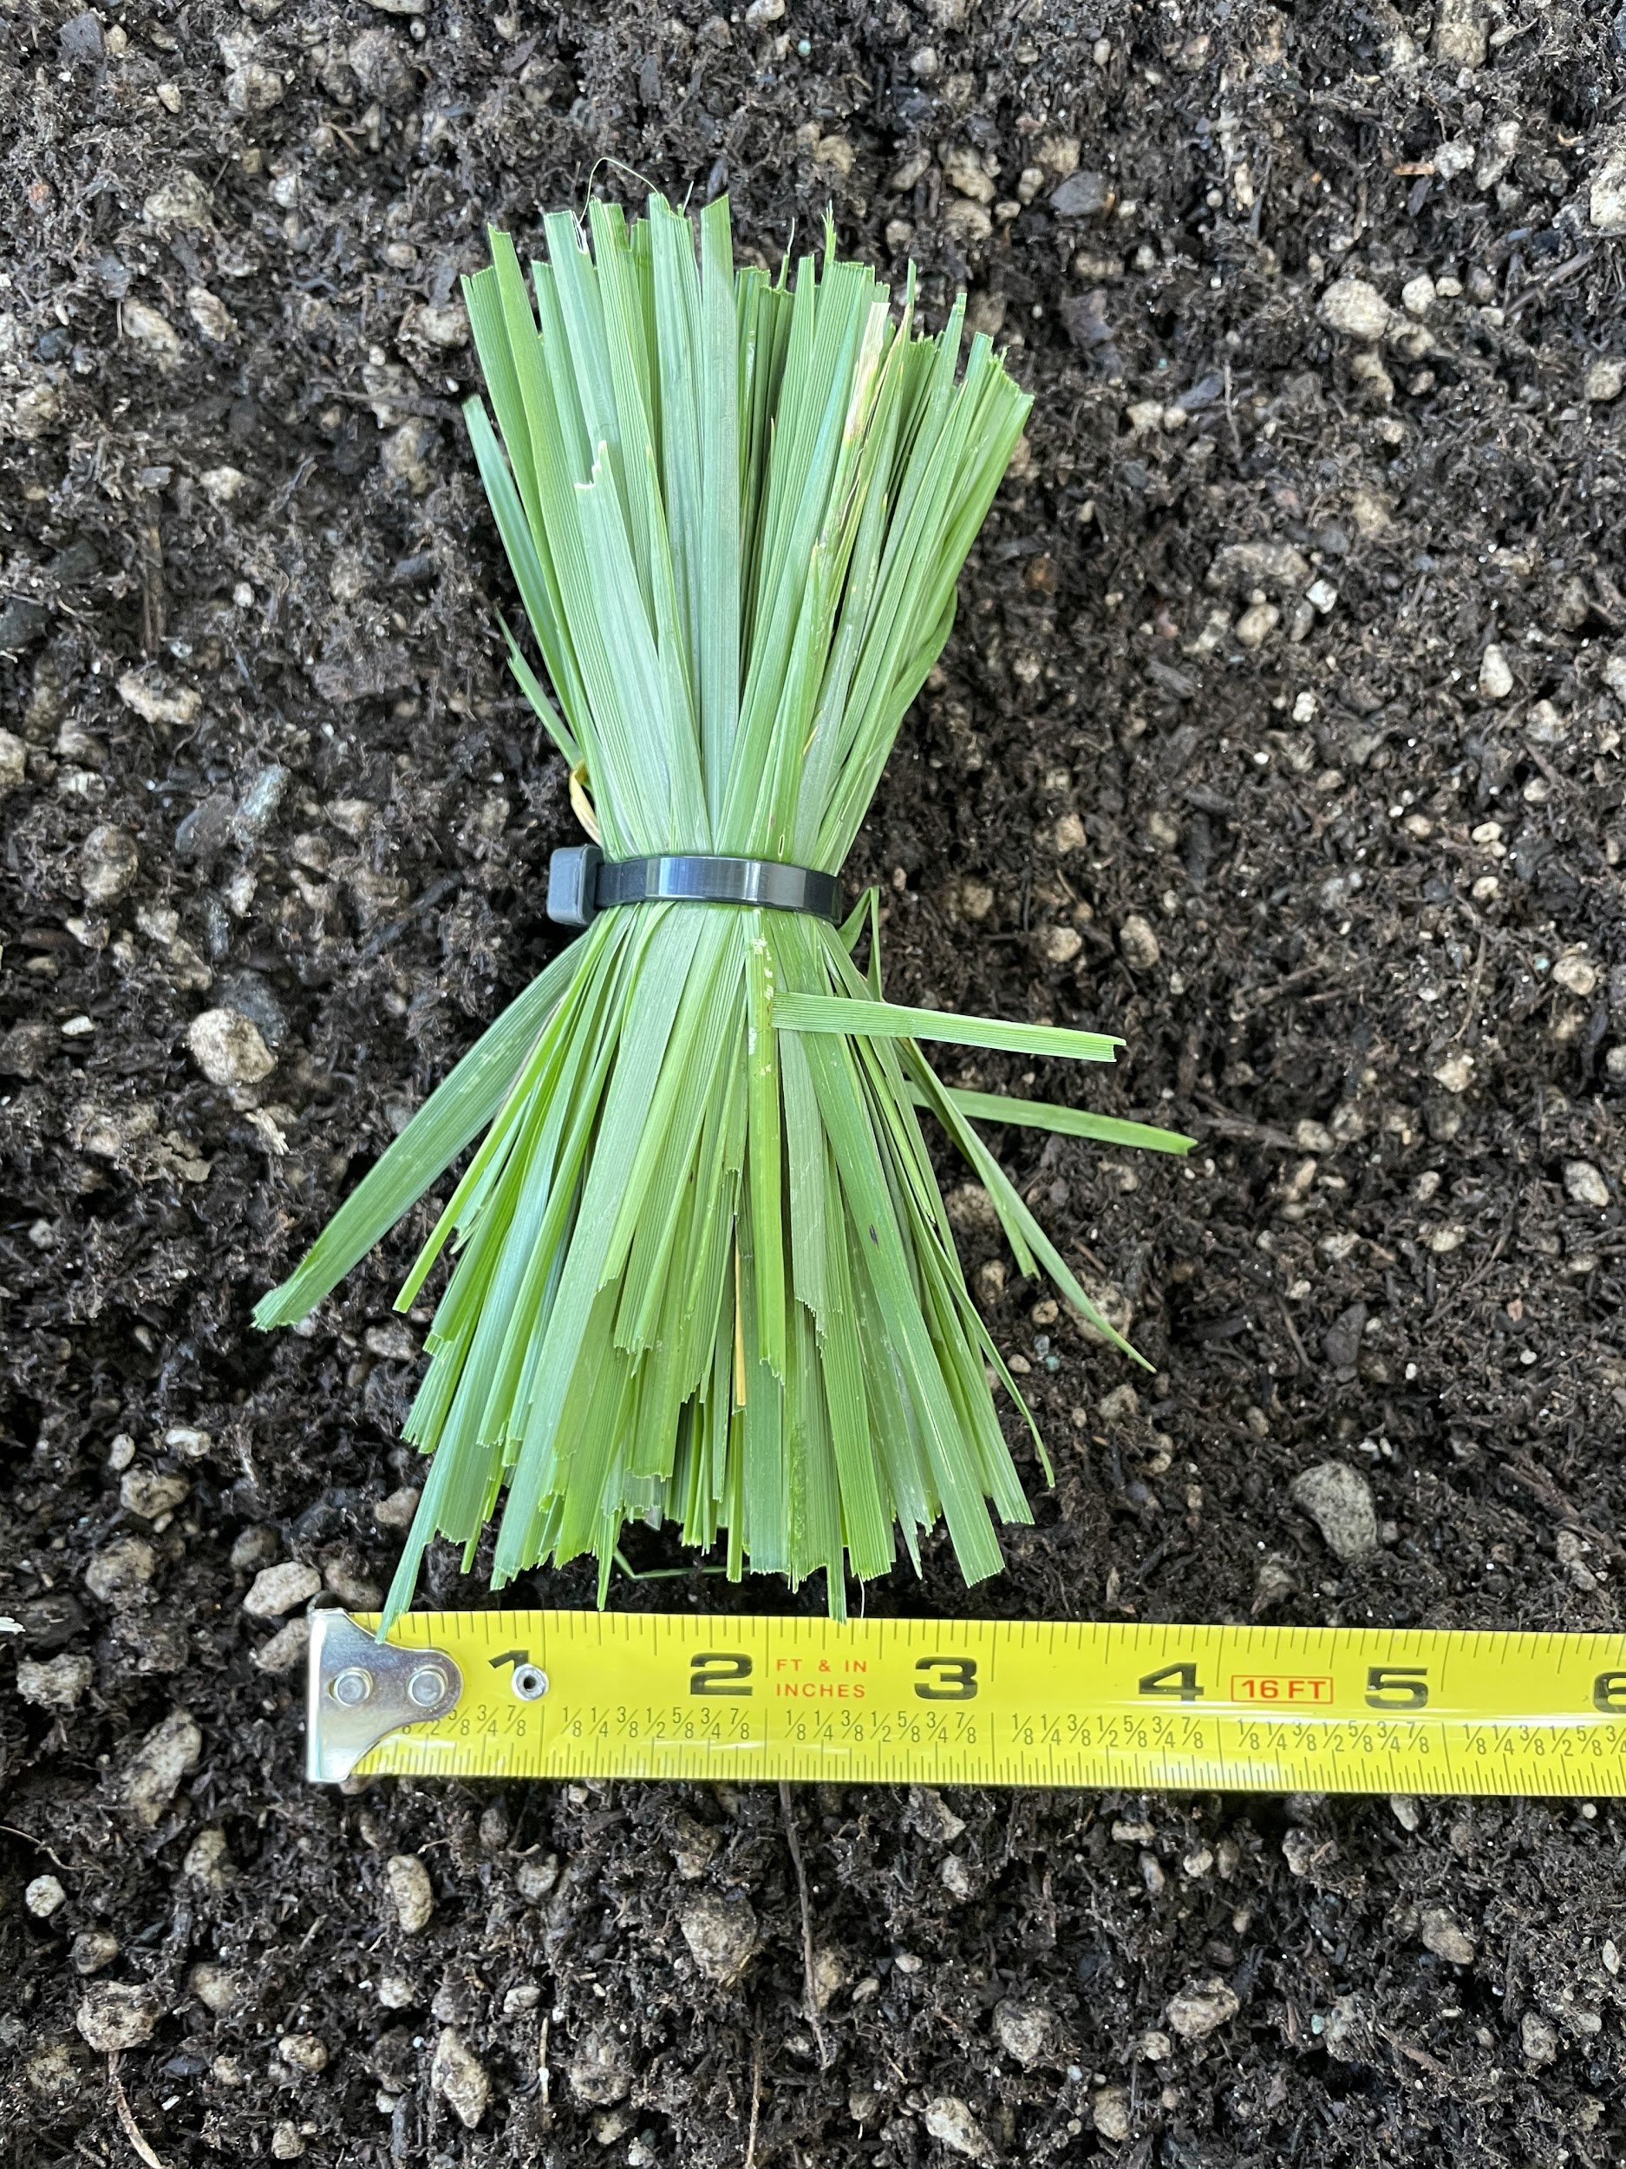

Figure 7.1.2: Grass sample used for testing

For the final testing setup , the grass sample was ‘planted’ in the dirt patch and the Weed warden was mounted to the cart at 16” (figure 7.3) and 12” (figure 7.4).



Figure 7.1.3: Weed Warden is mounted at 16” height for testing

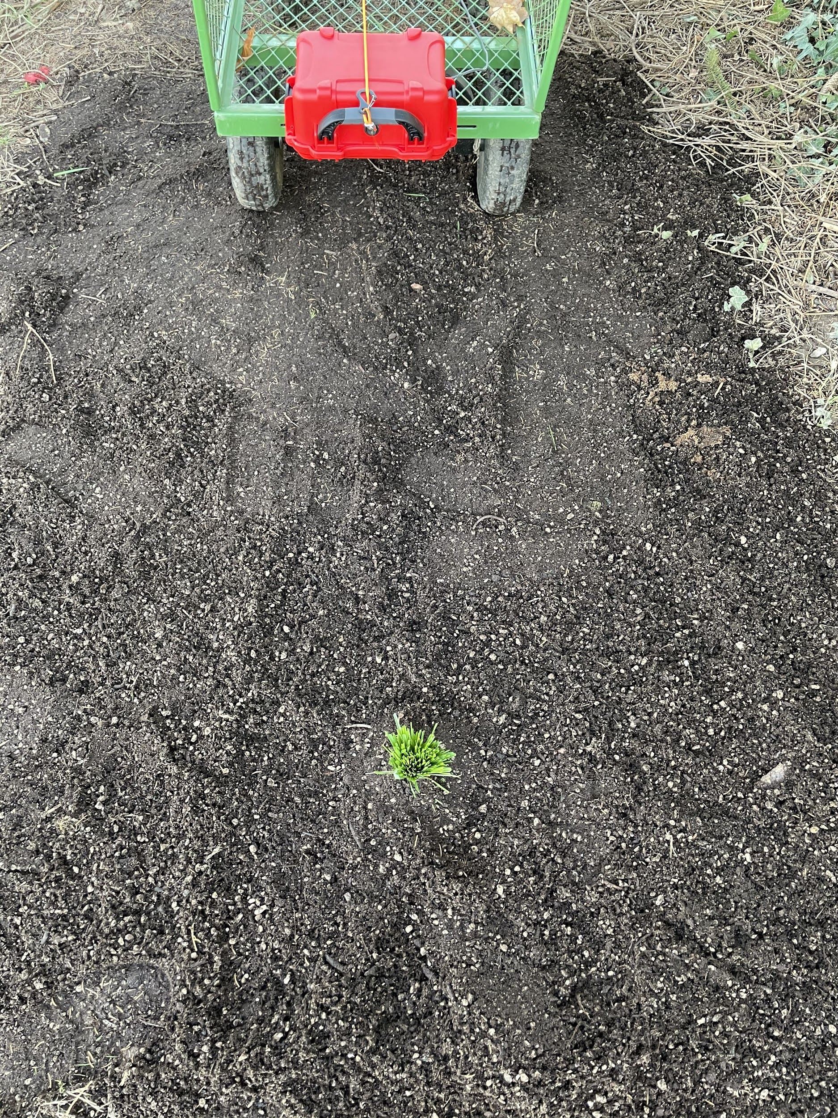

Figure 7.1.4: Weed Warden mounted at 12” height for testing

Once the setup was finished, the Weed Warden was powered on via USB cable from a laptop and the sensor was calibrated over the bare dirt patch. A video was also started at this time so that the time when the Weed Warden was above the grass could be matched to the data logged to the SD card. After calibration had been completed the Weed Warden was rolled over the grass sample then back to the dirt. Once this had been done a few times the Weed Warden was shut off and the video was stopped.

**7.2 Results**

After testing, the data can be processed in excel to show indicator values, threshold values, and video times were matched up to show when the grass was present underneath the sensor. Figures 7.2.1 and 7.2.2 show the raw spectral wavelength data that was logged to SD (lines a-w) as well as the presence of grass underneath the sensor (green shaded area).



Figure 7.2.1: Raw data taken from the triad sensor and vegetation presence on the Weed Warden for a 16-inch height test.



Figure 7.2.2: Raw data taken from the triad sensor and vegetation presence on the Weed Warden for a 12-inch height test.

Once the raw data has been collected, it can be run through several algorithms to determine the presence of vegetation under the sensor. The Weed Warden will compute the index of your choice and compare it to the calibration threshold value to determine the presence of vegetation. Three example indices have been calculated below for 16 and 12 Inch heights (Figures 7.2.3-7.2.4).



Figure 7.2.3: NDVIB, NDVI, EVI, and PSND indices plotted alongside vegetation presence for a 16-Inch Height.



Figure 7.2.4: NDVIB, NDVI, EVI, and PSND indices plotted alongside vegetation presence for a 12-Inch Height.

The recommended index for using the Weed Warden is the NDVIB index (figure7.2.5) or NDVI index (figure 7.2.6). The index used on the Weed Warden by default is the NDVIB index.

$$NDVIB =\frac{R_{760}+R_{810}+R_{860}+R_{510}+R_{535}+R_{560} - 2*(R_{435}+R_{460}+R_{485})}{R_{760}+R_{810}+R_{860}+R_{510}+R_{535}+R_{560} + 2*(R_{435}+R_{460}+R_{485})}$$

Figure 7.2.5: NDVIB Index Calculation

$$NDVI = \frac{R_{800}-R_{670}}{R_{800}+R_{670}}$$

Figure 7.2.6: NDVI Index Calculation

By using the NDVIB index, the calibration threshold value, and the presence of vegetation charts like the ones in figures 7.2.7 and 7.2.8 can be generated. These charts show the NDVIB index (blue) movement with relation to time and the presence of grass (green area). The chart also shows the calibration threshold value (black). It is clearly observed that when vegetation is present, the NDVIB index crosses the calibration threshold value which indicates that grass is detected and the 12V relay is turned on.



Figure 7.2.7: NDVIB index and calibration threshold value for a 16” height



Figure 7.2.8: NDVIB index and calibration threshold value for a 12” height

By observing the graphs above, the difference between 16-inch height and 12-inch height can be measured. The data from the 16-inch tests have smaller wavelength peaks and result in a less obvious detection.

1. **Acknowledgements** *[List here those individuals who provided help during the research (e.g., providing language help, writing assistance or proof reading the article, etc.).]*

*Please also identify who provided financial support for the conduct of the research and/or preparation of the article and to briefly describe the role of the sponsor(s), if any, in study design; in the collection, analysis and interpretation of data; in the writing of the report; and in the decision to submit the article for publication. If the funding source(s) had no such involvement then this should be stated.*

Funding for the development of this project was provided by Agricultural Research Foundation Competitive Grants Program, Marcello Moretti, Ryan Graebner, Chet Udell, and Oregon State University.

Special thanks to Dr. Chet Udell, Cara Walter, and Dr. John Selker for their continued support and guidance throughout this project.

The author acknowledges Brendan Miller, Colton Shaw, and Alissa Bergquist for their work during the early stages of this project.

We gratefully acknowledge the assistance of Gordon Godshalk for proofreading the article. This work is financially supported by the USDA National Institute of Food and Agriculture, Hatch project NI18HFPXXXXXG055 and the National Science Foundation award #1832170. The sponsors were not involved in the conduction of the research or preparation of this article.

1. **Declaration of interest** *[a statement must be included even if there is no conflict of interest]*

*All authors must disclose any financial and personal relationships with other people or organizations that could inappropriately influence (bias) their work. Examples of potential conflicts of interest include employment, consultancies, stock ownership, honoraria, paid expert nm testimony, patent applications/registrations, and grants or other funding. Authors must disclose any interests in a summary declaration of interest statement in the manuscript file. If there are no interests to declare then please state this: 'Declarations of interest: none'. This summary statement will be ultimately published if the article is accepted.* [*More information*](http://service.elsevier.com/app/answers/detail/a_id/286/supporthub/publishing).

Declarations of interest: none

1. **Human and animal rights**

The work does not use any human or animal subjects.

**References:** *[Include at least one reference, to the original publication of the hardware you customized. Include other references as required. Include references to put your device in context in the literature. For more information on the reference format in HardwareX please see the Guide for Authors at:* [*https://www.elsevier.com/journals/hardwarex/2468-0672/guide-for-authors*](https://www.elsevier.com/journals/hardwarex/2468-0672/guide-for-authors)*]*

# References

|  |  |
| --- | --- |
| [1] | NASA , "Measuring Vegetation (NDVI & EVI)," NASA , 30 August 2000. [Online]. Available: https://earthobservatory.nasa.gov/features/MeasuringVegetation/measuring_vegetation_2.php. [Accessed 26 April 2021]. |
| [2] | ecoRobotix, "Smart Weeding," ecoRobotix, [Online]. Available: https://www.ecorobotix.com/en/autonomous-robot-weeder/. [Accessed 26 4 2021]. |
| [3] | L. Ada, "Adafruit Feather M0 Basic Proto," Adafruit , 21 April 2021. [Online]. Available: https://learn.adafruit.com/adafruit-feather-m0-basic-proto/assembly. [Accessed 26 April 2021]. |
| [4] | B. Nguyen and B. Goto , "Hypnos," OPEnS Lab, 28 December 2020. [Online]. Available: https://github.com/OPEnSLab-OSU/OPEnS-Lab-Home/wiki/Hypnos. [Accessed 26 April 2021]. |
| [5] | B. Nguyen , B. Goto , J. Selker and C. Udell, "Hypnos Board: A Low-Cost All-In-One Solution for Environment Sensor Power Management, Data Storage, and Task Scheduling.," Manuscript submitted for publication, 2021. |
| [6] | K. Kang, "Loom Quick Start Guide," OPEnS Lab , 28 January 2020. [Online]. Available: https://github.com/OPEnSLab-OSU/Loom/wiki/Quick-Start. [Accessed 26 April 2021]. |

_____________________________________________________________________________________

Additional Information for authors.(do not include these lines in your submission)

**Author manuscript checklist**

* HardwareX is a journal dedicated to the exhaustive and fully open source communication of advances in scientific infrastructure. Upon submission the author declares that all information necessary to reproduce the subject of the submission (e.g. bill of materials, build instructions, calibration procedures, source files, code, and safety considerations) is communicated in full and is accessible for use under an open source license.
* Is the subject of the submission under an open source license - as defined by the [Open Source Hardware definition](http://www.oshwa.org/definition/)?
* Can the hardware be reproduced with the details provided in the submission?
* Are all relevant design files available on Mendeley Data, the Open Science Framework, or Zenodo repositories, described in the Summary of Design Files document, and clearly documented? (e.g. descriptive file names, commented code, labeled images, etc.)
  + If in the Open Science Framework, the repository has be registered? [Instructions](https://osf.io/wgk7q/wiki/home/)
  + If in Zenodo, the repository is open access and is published? [Instructions](https://doi.org/10.5281/zenodo.3346799)
  + If in Mendeley Data, the repository is published or the sharable link was included in the additional information of the Editorial Submission interface? [Instructions](https://doi.org/10.5281/zenodo.3346799)
* Are visual instructions used when necessary?
* Is the utility of the hardware to the scientific community?
* Is the performance of the hardware adequately demonstrated and characterized?
* Are all potential safety concerns addressed?
* For more information on the article template consult the [Guide to Authors](https://www.elsevier.com/journals/hardwarex/2468-0672/guide-for-authors).